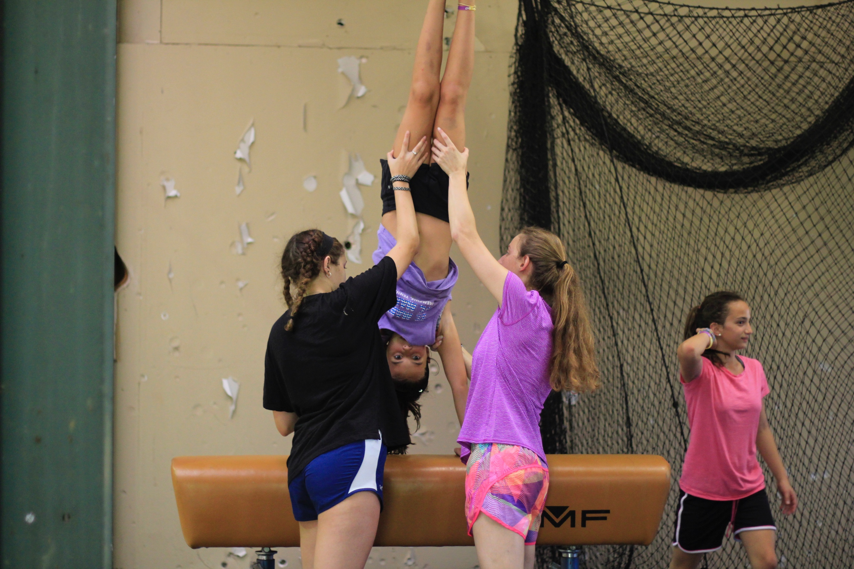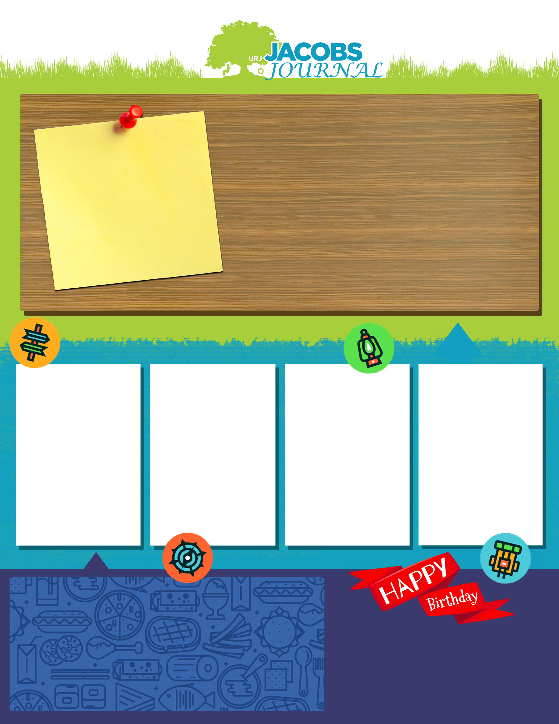

Breakfast: french toast sticks and eggs

Lunch: pizza and green beans

Dinner: turkey, dressing, peas

Happy 12th birthday, Sarah!

What’s on the Menu?

Gymnastics is taking over Jacobs Camp!

Talmidim had their first campout of the summer! They loved climbing the tower!

Maskilim designed and promoted their own new cereal brands!

Garin made and decorated cakes to participate in Jacobs Camp Cake Boss!

Olim loved playing sports and learning the value of teamwork!